* 12/6
  + Tried basic tutorial on water fluid flow
  + Put in helical venting pot
    - Displayed direction field, hit x for cross sectional view
    - Smoke is moving really slowly inside the vent (before edits that Dr. Read suggested, so maybe it’s just that the vents aren’t big enough for much air to come through)
    - 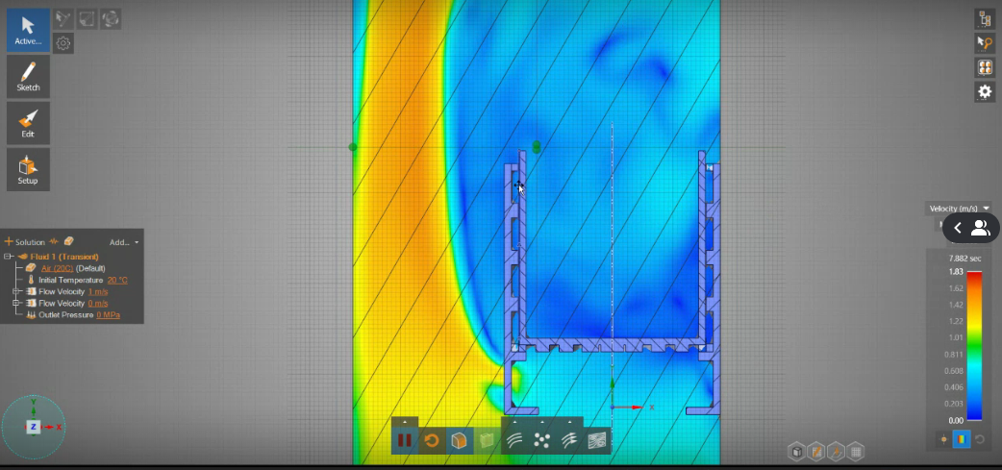
    - 
* Made outside layer really thick and vents really large
  + 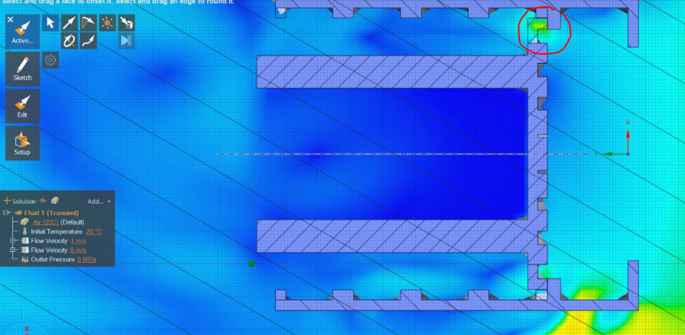
  + Looks like the vents are being blocked a bit? Which corroborates what Sam was talking about when he printed the helical vane pot
* Moved inner layer up a lot just to see what it would be like if there’s no blockage at the bottom of the pot
  + 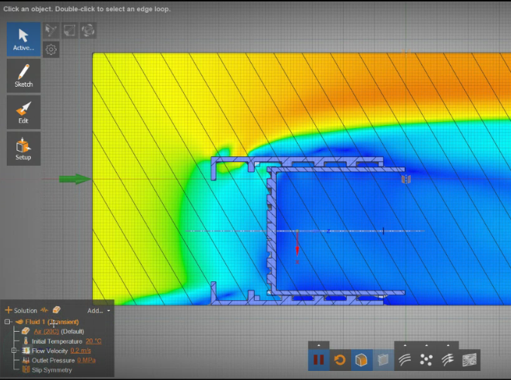
  + Air moves really slowly inside vents for now, which might be a good thing if there’s longer time exposure between the smoke in the vents and the walls of the pot
* Adding an emitter to see the flow of air particles
  + 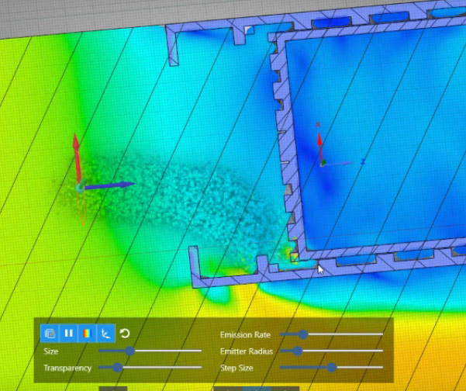
  + Seems like the particles disappear as soon as they contact the surface, so can’t really see the movement of the particles inside the vents